To create one or more IAM users with the AWS Management Console

STEPS:

1)Sign in to the Identity and Access Management (IAM) console at <https://console.aws.amazon.com/iam/>.

2)In the navigation pane, choose Users and then choose Create New Users.

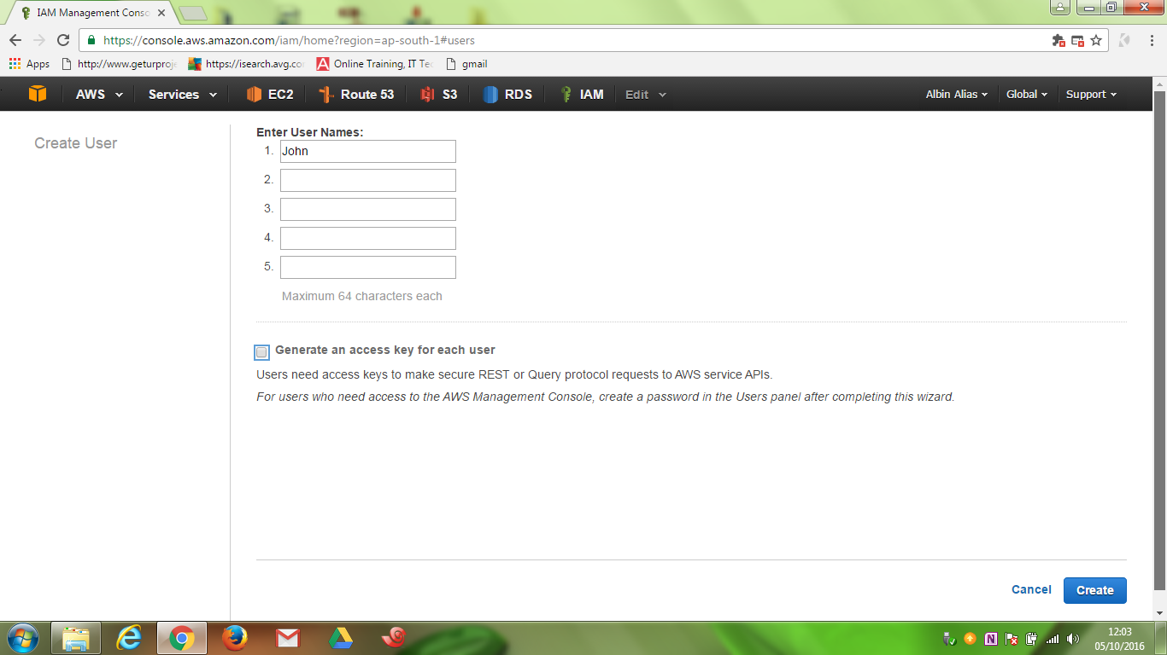

3)Type the user names for the users to create. We can create up to five users at one time.

4)If the users require access to the API, AWS CLI, or Tools for Windows PowerShell, then they must have access keys. To generate access key for new users at this time, select Generate an access key for each user.

5)Choose Create.

6)To view the users' access keys choose Show User Security Credentials. To save the access keys, choose Download Credentials and then save the file to a safe location on our computer.

We will not have access to the secret access keys again after this step.

7)Give the user(s) permission to manage their own security credentials. For more information, see Allow Users to Manage Their 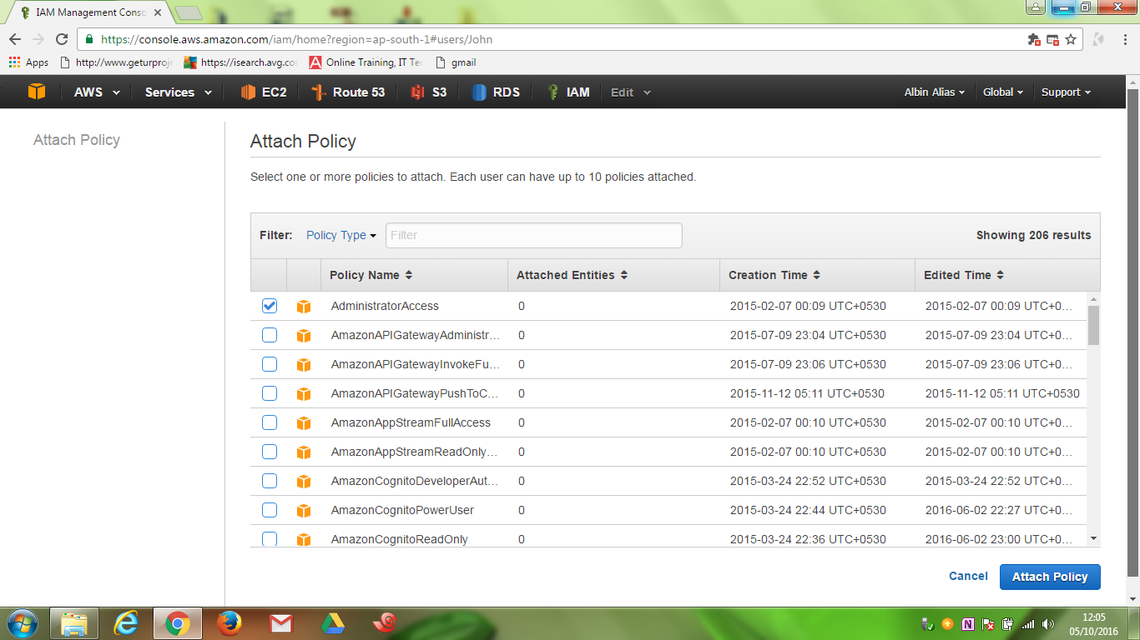Own Passwords, Access Keys, and SSH Keys.

8) To enable the user(s) to access the AWS Management Console, create a password for each user. For more information, see Creating, Changing, or Deleting an IAM User Password (AWS Management Console).

9) Make the user a member of a group that has policies attached that provide the appropriate permissions for this user to access AWS resources. We recommend using groups rather than attaching policies directly to users. For more information, see Attaching Managed Policies.

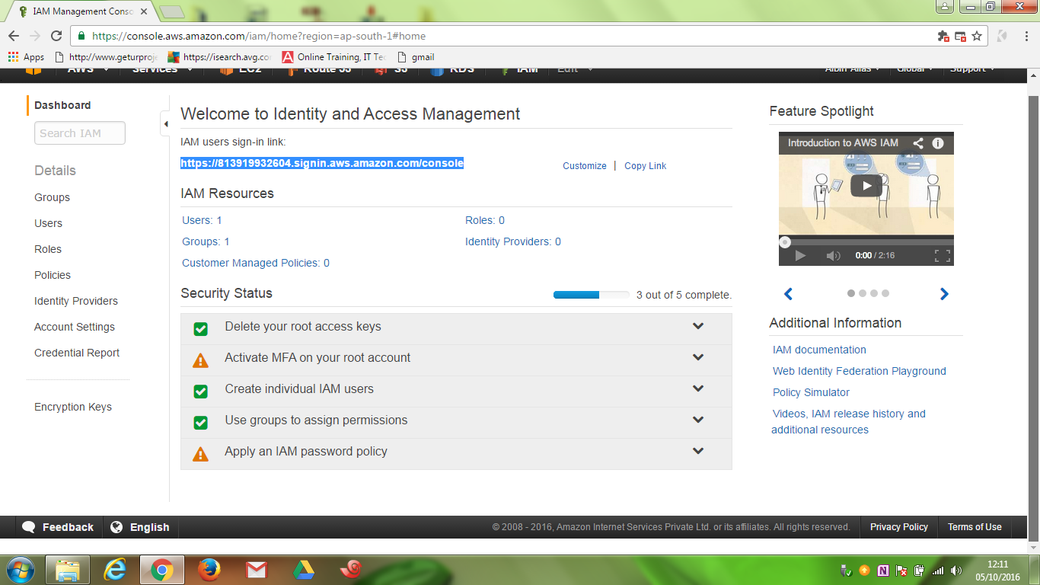

10)Provide each user with his or her credentials:

User name

Password and/or access keys

URL to the account sign-in web page.

